Assignment-2.5
Name: Kanukuntla Shailaja
Ht.No:2303A52155
Batch-34
Task 1: Refactoring Odd/Even Logic (List Version)

- Scenario:
You are improving legacy code.

- Task:
Write a program to calculate the sum of odd and even numbers in a list, then refactor it using AI.

Original Code:
Prompt: Program to calculate sum of odd and even numbers in a list
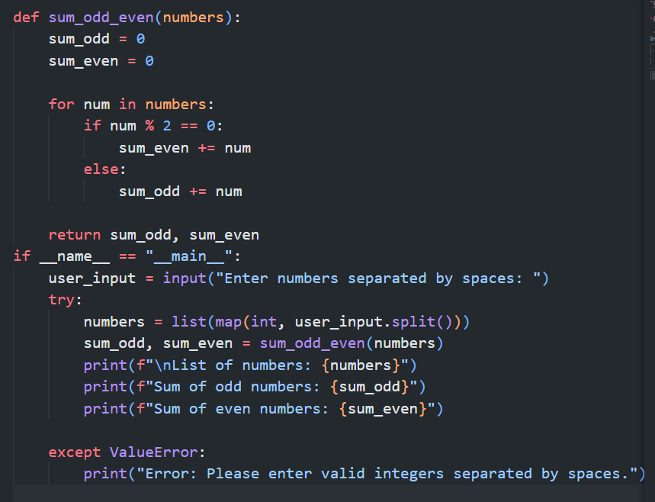

Optimized Code:
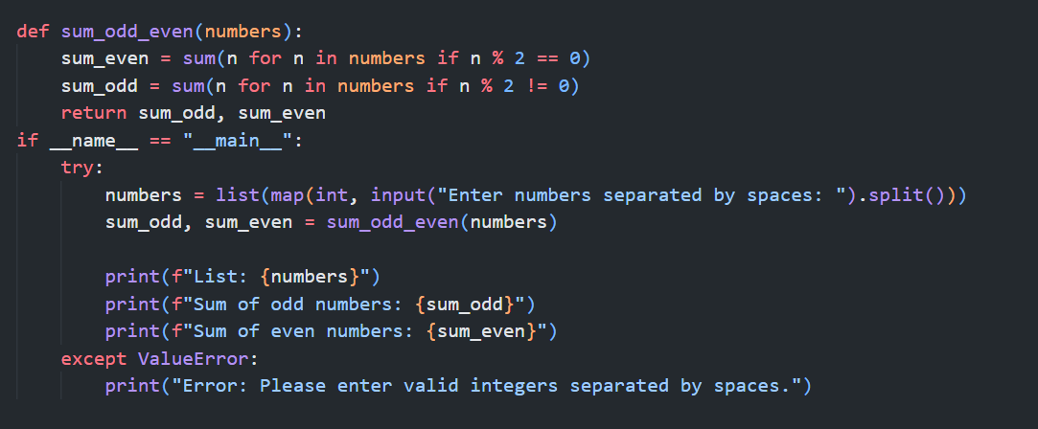
Output:

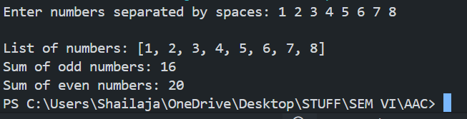

Justification:
The refactored code is better because it produces the same output with fewer lines and cleaner logic. It uses Python’s built-in sum() function with generator expressions, which improves readability and reduces manual variable handling. Both versions have the same time complexity, but the refactored version is easier to understand and maintain.

Task 2: Area Calculation Explanation

- Scenario:
You are onboarding a junior developer.

- Task:
Ask Gemini to explain a function that calculates the area of different shapes.
Prompt:
Refactor a Python function that calculates the area of different shapes (circle, rectangle, triangle).
Optimize the code for readability and maintainability by avoiding repeated conditional logic.
Use clean structure, meaningful variable names, and Python best practices.
Handle invalid shape input gracefully.
Return only the optimized code and include brief inline comments explaining the logic.
Code:
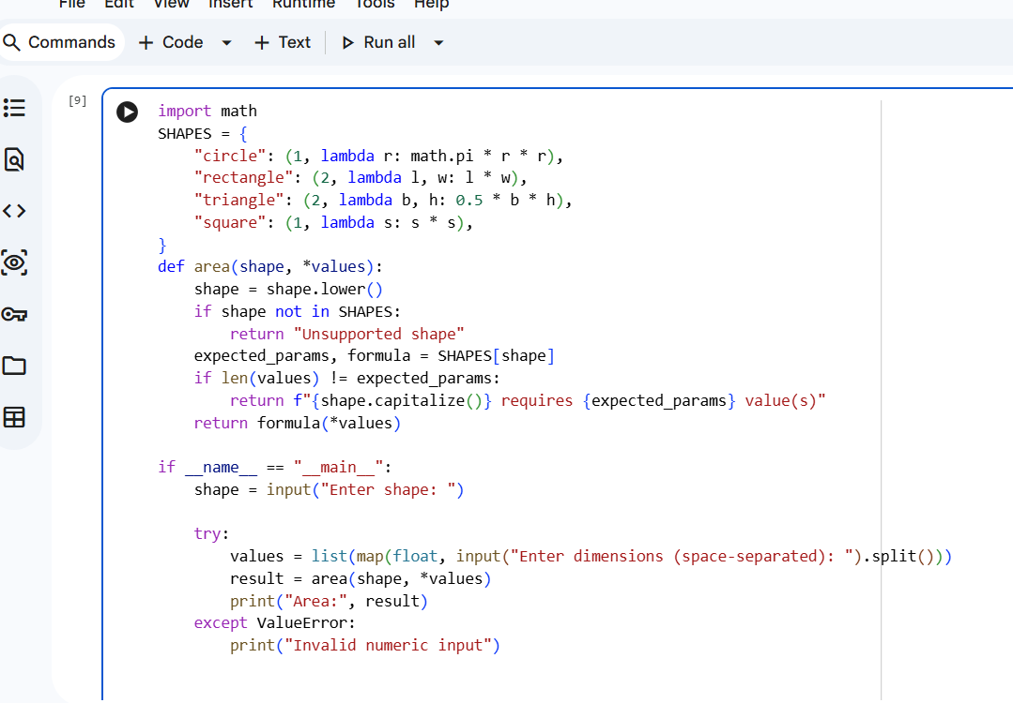

Output:
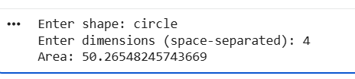
Explanation:
The math module is imported to access mathematical constants such as math.pi, which is required for calculating the area of a circle.
Helper functions like _calculate_circle_area, _calculate_rectangle_area, and _calculate_triangle_area are defined to compute the area of specific shapes. Each helper function accepts **kwargs to receive shape-specific dimensions, retrieves the required values using .get(), and validates that the inputs are positive numeric values. If validation fails, a ValueError is raised. If validation passes, the appropriate area formula is applied and the result is returned.
A dictionary named _shape_calculators maps shape names to their corresponding helper functions. This enables dynamic dispatch and avoids long if/elif conditional chains, making the code cleaner and easier to extend.
The main area function takes a shape name and keyword arguments for dimensions. The shape name is normalized to lowercase to ensure case-insensitive input handling. The function retrieves the appropriate calculator function from _shape_calculators. If the shape is unsupported, a descriptive ValueError is raised listing valid shapes. Otherwise, the selected helper function is called with the provided arguments, and the computed area is returned.

Task 3: Prompt Sensitivity Experiment

- Scenario:
You are testing how AI responds to different prompts.

- Task:
Use Cursor AI with different prompts for the same problem and observe code changes.
Prompt: Write a Python program to calculate the sum of odd and even numbers in a list.
Code:

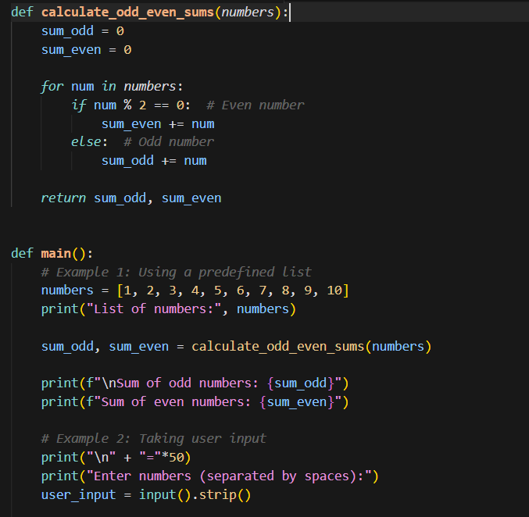
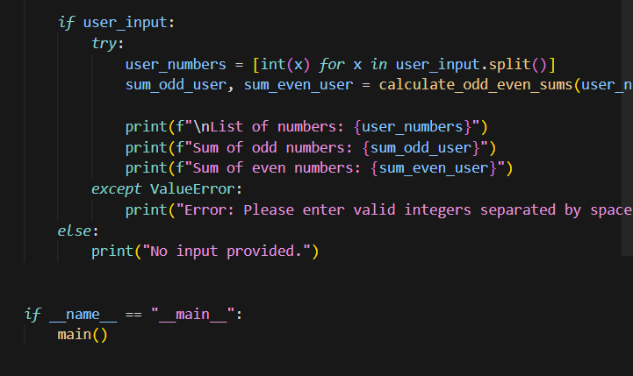

Prompt2: Write an optimized Python function to calculate the sum of odd and even numbers using clean and readable code.
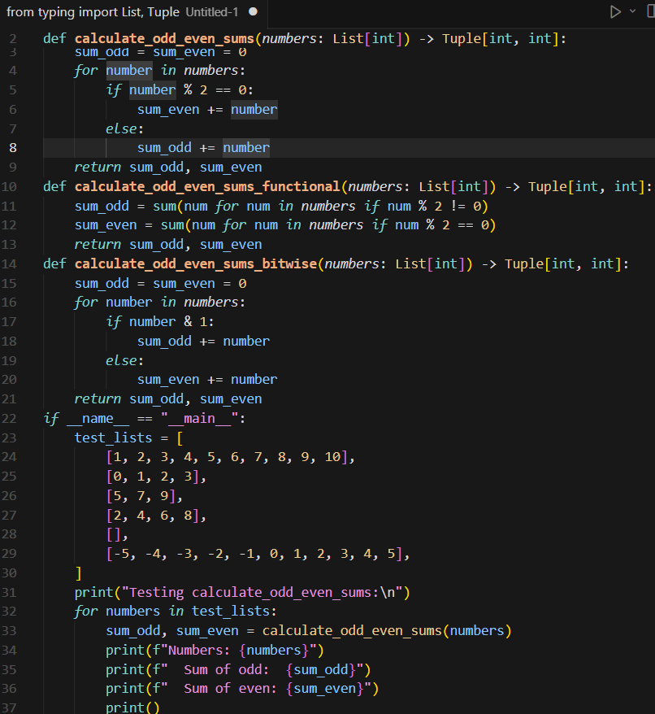
Prompt3: Refactor the Python code to calculate odd and even sums using Python best practices and minimal lines of code.
Code:
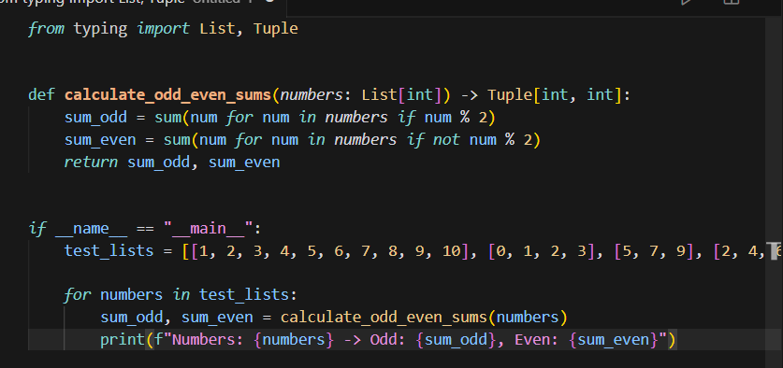

Code 1 uses a procedural approach with explicit loops, conditionals, and user input handling. It is easy to understand and suitable for beginners but is longer and less optimized.
Code 2 provides multiple implementations (iterative, functional, and bitwise) using type hints. It focuses on optimization and comparison of different techniques rather than simplicity.
Code 3 uses a single, Pythonic function with generator expressions. It is concise, readable, and follows best practices with minimal code.

Key Differences
- Code 1 prioritizes clarity and learning.
- Code 2 emphasizes optimization and multiple approaches.
- Code 3 focuses on minimal, clean, and maintainable code.

Best Code
Code 3 is the best choice because it achieves the same functionality with the least code, high readability, and better maintainability.

Task 4: Tool Comparison Reflection

- Scenario:
You must recommend an AI coding tool.

- Task:
Based on your work in this topic, compare Gemini, Copilot, and Cursor AI for usability and code quality.

Prompt: Gemini
Explain and refactor a Python program that calculates the sum of odd and even numbers in a list.
Provide clean, readable code and explain how the logic works step by step in simple terms.
Focus on clarity and beginner-friendly explanation.

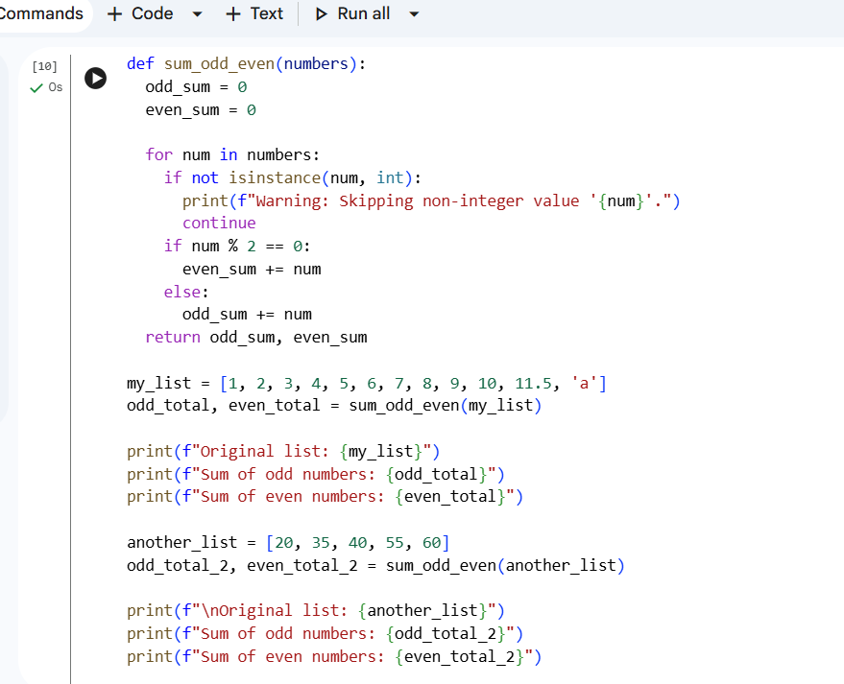

Prompt: Copilot
# Write an optimized Python function to calculate the sum of odd and even numbers in a list
# Use clean logic and minimal lines of code
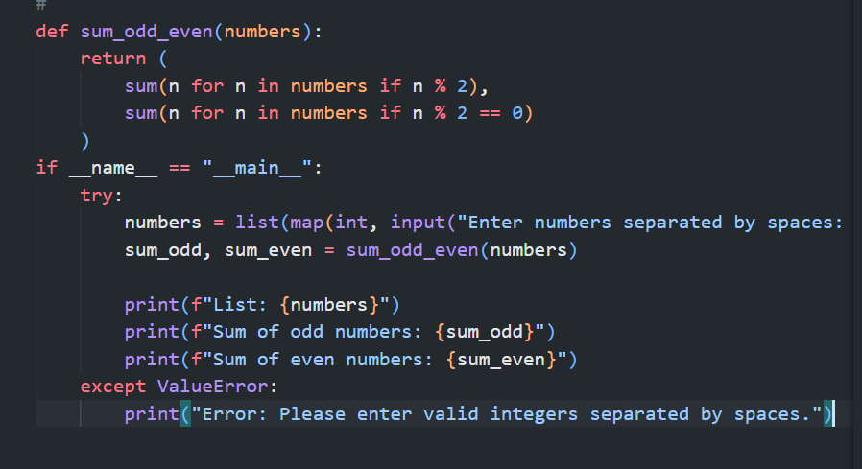

Prompt: Cursor AI
Refactor the given Python code that calculates odd and even sums.
Optimize for readability, minimal lines, and Python best practices.
Remove unnecessary logic and return only the improved code
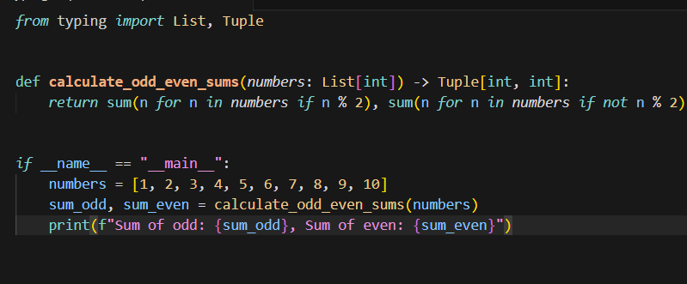

Reflection:
The first version is defensive and verbose. It validates input types, skips invalid values, and prints warnings. This improves robustness but increases code length and reduces clarity. It is suitable for learning and real-world data handling, not for optimization.
The second version is concise and optimized. It uses generator expressions and user input handling with minimal logic. The focus is on clean computation rather than validation. This is a typical result when the prompt emphasizes optimization and minimal code.
The third version is the most Pythonic and minimal. It uses type hints and pure functional logic with no extra control flow. It is easy to read, maintain, and ideal for demonstrations or production code where inputs are trusted.
Conclusion:
The third version is the best in terms of readability, maintainability, and code quality. The first prioritizes safety, while the second balances usability and optimization. This clearly shows how different prompts lead to different AI-generated solutions.

